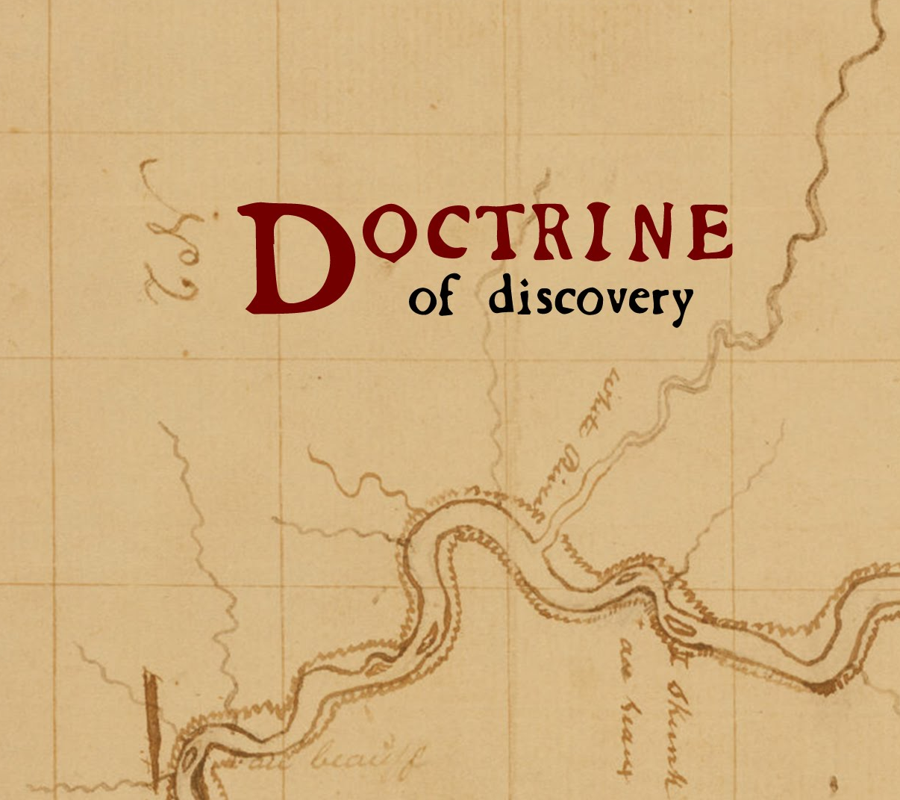
Dismantling
the Doctrine of Discovery

4 October 2016, 7:30 to 9:30 pm.
Emmanuel Baptist Church
2121 Cedar Hill Cross Rd, Victoria, BC

Film, lecture, discussion
Since 1493, ideas & laws based on the “Doctrine of Discovery” were used to justify European sovereignty over Indigenous lands & peoples around the world. In 2015, Canada’s Truth and Reconciliation Commission (TRC) called upon churches to repudiate this 15th century doctrine.

What is the Doctrine of Discovery? Why should Christians reject it?
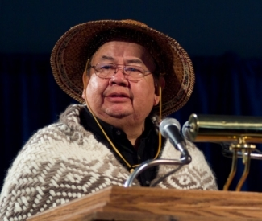
Watch a 43-minute film that explains the Doctrine of Discovery from a contemporary Christian perspective including how it has affected Indigenous Peoples in North America.

Seenupin, Chief Andy Thomas, Hereditary Chief, Esquimalt First Nation, will open the event.

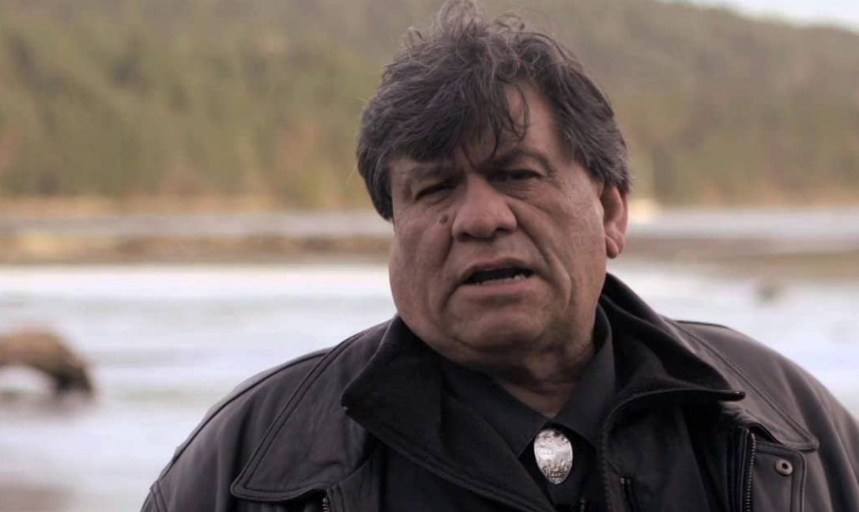
Hear noted lawyer, Tl’ul’thut, Robert Morales, explain how the Doctrine of Discovery gave legal cover to a massive corporate land grab on Vancouver Island over a century ago. Discussion to follow. Robert Morales is Coast Salish and a member of Cowichan Tribes. Robert Morales, is the Chief Negotiator and lawyer for the Hul’qumi’num Treaty Group (HTG) on Vancouver Island. He represented the HTG in the Inter-American Commission on Human Rights and as intervener in the landmark Tsilhqot'in case in the Supreme Court of Canada.

Introduced & moderated by Catherine Morris, managing director of the charitable organization Peacemakers Trust & Adjunct Professor at UVic’s Faculty of Law. Catherine attends Emmanuel.

Significant Conversations: This event is part of Emmanuel’s Significant Conversations series.

Post-secondary students: This event follows Emmanuel’s no-strings-attached student dinner served free of charge to hundreds of students Tuesdays at 6 pm during the school term. (Arrive by 5:15pm to avoid a line up for dinner – earlier if you are in a group).

Everyone welcome! Free of charge.

